**FEEDBACK AMPLIFIER WITH CLOSED LOOP**

AIM:

Design a Feedback Amplifier with close loop using Op Amp of Output Resistance 1KΩ.

Given:

A = 200 V/V, Rin = ∞, Rout = 10KΩ

1. Without Feedback Loading
2. With Feedback Loading

APPARATUS REQUIRED:

LTSpice Software.

THEORY:

Rout’ = Rout / (1+AK)

1K = 10K / (1 + 200*K)

1 + 200*K = 10

K = 9/200 = 0.045

**Without feedback loading**

Circuit:

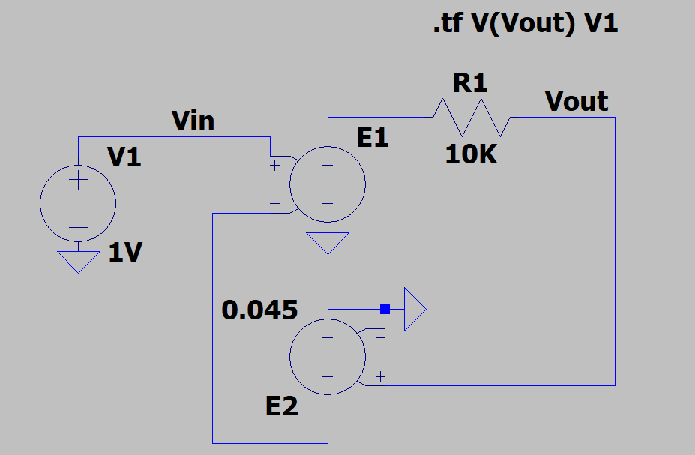

Output:

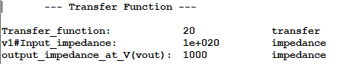

**With feedback loading**

**Considering Rin as infinity**

Circuit:

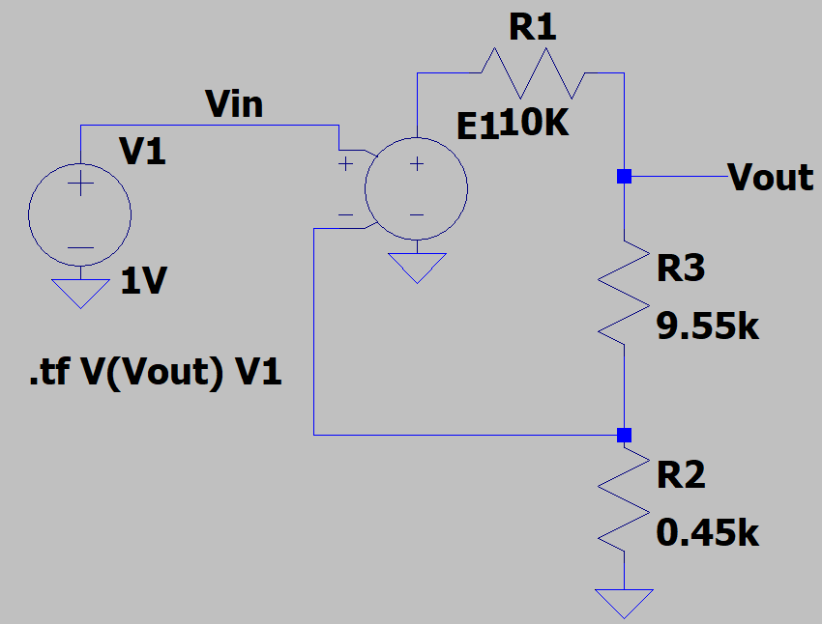

Output:

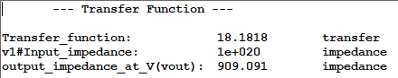

**Considering Rin as 1MΩ**

Circuit:

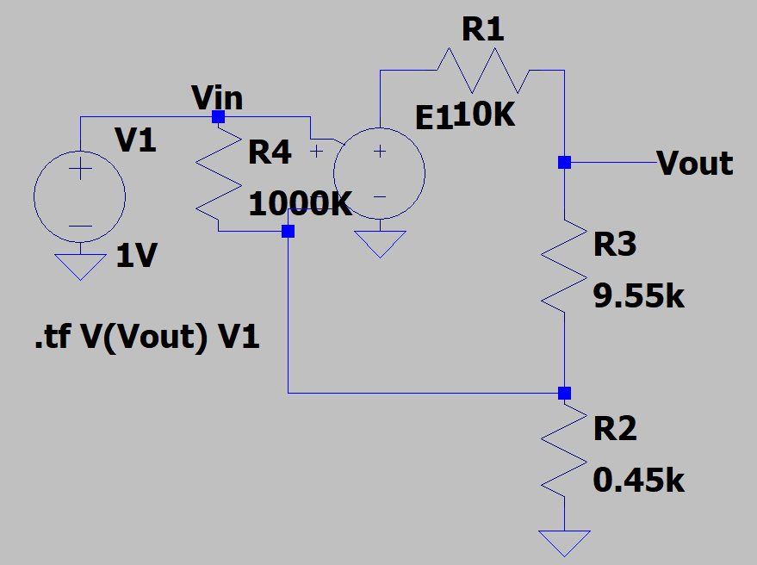

Output:

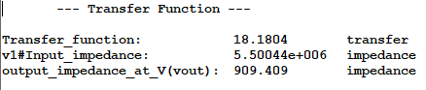

RESULT:

The transfer function decreases when feedback loop is considered non ideal , and also when input impedance is decreased.